Form-Subform Data Entry and Data Editing

Suppose you want to add Microsoft Office Certification to the list of educational qualifications of Mr. Osaki, the RC-Charter2 Director of Operations. The form/subform data editing/entry format shown in Figure 1 would be very useful, because it helps ensure that the educational qualifications entered for Mr. Osaki are, in fact, related to Mr. Osaki. The subform’s Education combo box format ensures data entry uniformity and it makes the data entry easier to handle, too.

Figure 1 Initial Form/Subform Data Entry
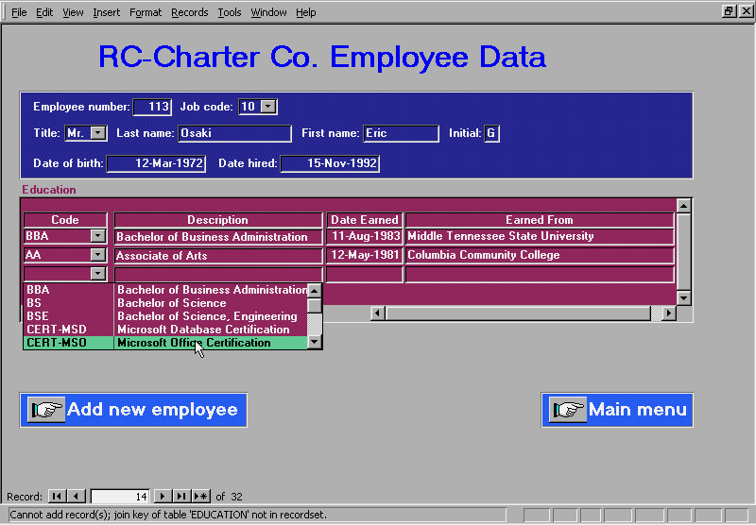

Unfortunately, if you examine the form in Figure 1 carefully, you’ll see that the attempt to add the Microsoft Database Certification to the list of Mr. Osaki’s educational achievements shown in the subform yields the error message

Cannot add record(s); join key of table ‘EDUCATION’ not in recordset.

To determine the reason for the error message, let’s take a look at the subform’s properties shown in Figure 2. Note that the child and master fields do appear to create the expected relationship between the EMPLOYEE and EDUCATION tables, because EMP_NUM is the primary key in EMPLOYEE and it is the foreign key in EDUCATION. Clearly, the problem is not with the notion of creating the main form/subform link through EMP_NUM. The more likely culprit is the data source definition for the subform’s EMP_NUM. Figure 3 shows that this data source is a query named

qryEmployeeEducation-mod

Figure 2 The Subform’s Properties
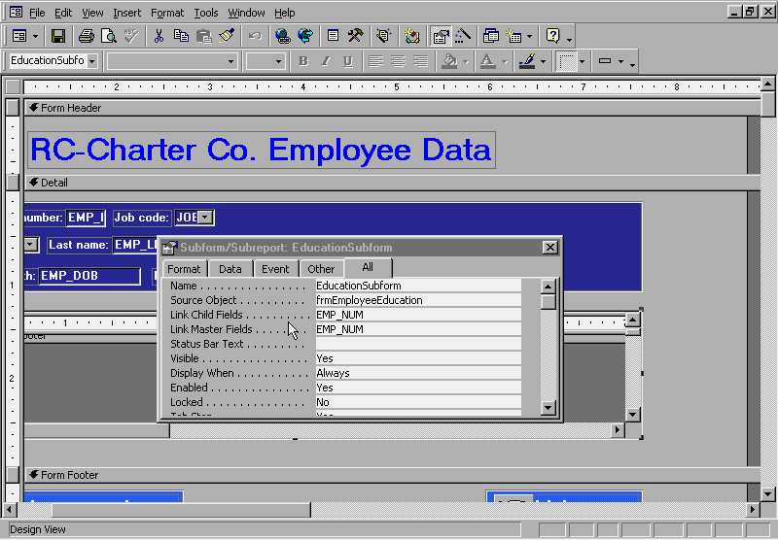

Note: To see the child/master link in Figure 2, first open the properties box, click outside the main form’s margin to see the main form properties, and then scroll down below the subform’s lower margin to generate the subform’s properties as they are related to the main form. If you just click on the subform without first clicking on the main form, you’ll not see the subform’s child and master fields definitions.

Figure 3 The Data Source for the Employee Subform
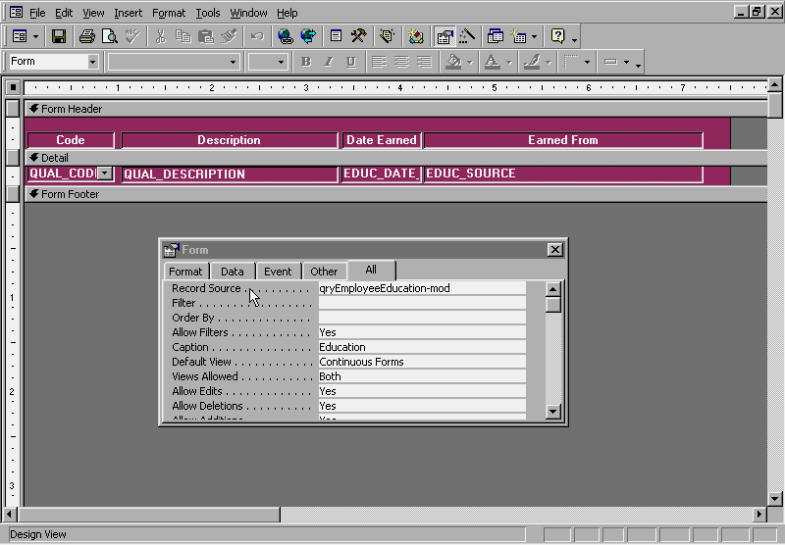

The reason for the error message shown in Figure 1 is evident in Figure 4. The subform’s EMP_NUM source is the EMPLOYEE table, rather than the EDUCATION table. Therefore, the link between the employee and education could not be established.

Figure 4 The Initial Employee Subform Data Source
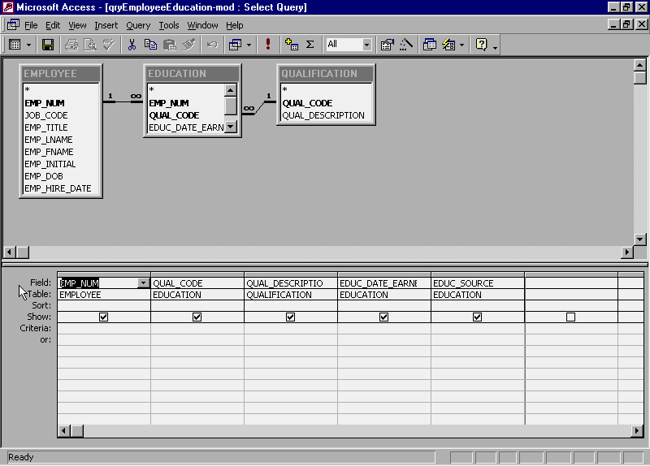

Given the 1:M relationship between the EMPLOYEE and EDUCATION tables, the main form must use the master EMP_NUM value derived from the EMPLOYEE table, while the subform must use the child EMP_NUM value found in the EDUCATION table. Therefore, all it takes to correct the problem is to modify the qryEmployeeEducation-mod query to make the EDUCATION table the source of the EMP_NUM attribute. (See Figure 5.) Clearly, the error message in Figure 1 was sufficiently explicit to guide you to a proper problem diagnosis and correction.

Figure 5 The Corrected Employee Subform Data Source
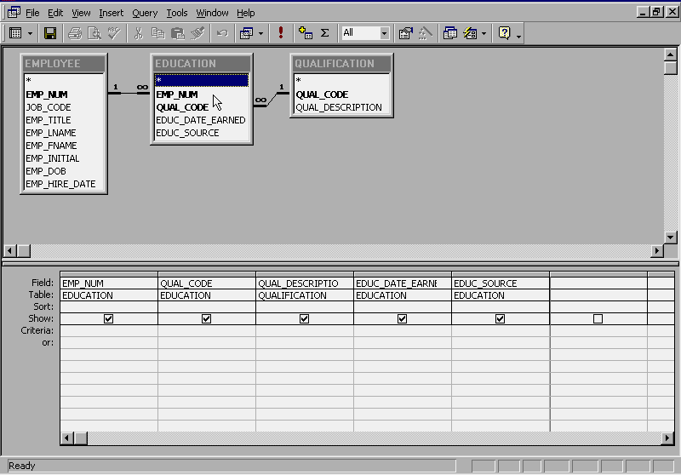

Figure 6 shows that the query correction yields the appropriate results. Note that we have successfully added the Microsoft Database Certification to the subform and that we are about to add a Commercial Pilot certificate to Mr. Osaki’s list of educational achievements.

Figure 6 Data Entry After the Correction
